Order Of Service

Singing: Psalm 89—CW page 98

Reading: Psalm 94

Opening Hymn: CW 260

Reading: II Timothy 1:1-18

Request Hymn: CW Supplement 769

Reading: Luke 4:33-44

Sermon Hymn: CW 363

Sermon Text: Acts 7:6-7

A Strange Land

Prayer

The Apostles’ Creed, TLH page 12

Holy Communion

The Lord's Prayer

The Blessing

Closing Hymn: CW 169

************

Koinonia Hour

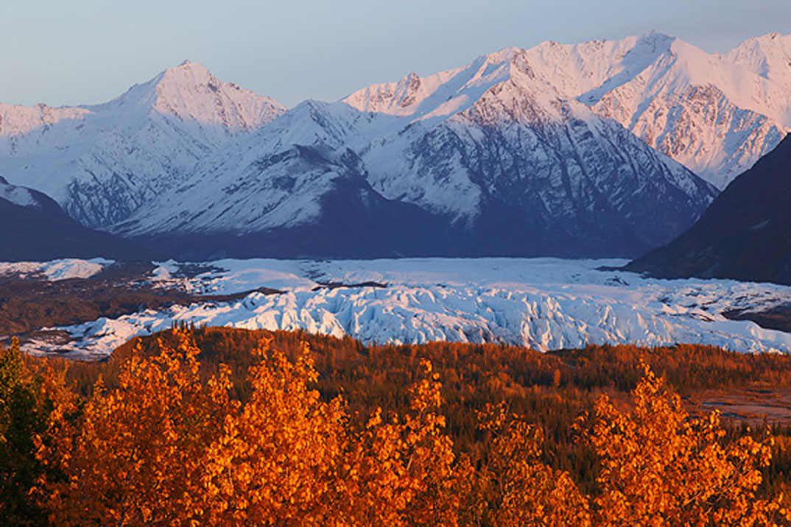

Fall In Alaska

Water
Of
Life

2 June 2024

W A T E R O F L I F E

Independent Christian Church—Conservative Lutheran Doctrine

Worship Service: 9:30 a.m.

Larry Cooper, Pastor E-Mail address:
lcooper@wateroflife.cc
Web Site:
www.wateroflife.cc

* * * * * * * * * * * * * * * * * * * * * * * * * * *

Sermon Text: Acts 7:6-7

A Strange Land

* * * * * * * * * * * * * * * * * * * * * * * * * * *

6 And God spake on this wise, That his seed should sojourn in a strange land; and that they should bring them into bondage, and entreat them evil four hundred years.
7 And the nation to whom they shall be in bondage will I judge, said God: and after that shall they come forth, and serve me in this place.

